Postal Life Insurance

Department of Post

Software Requirements Specification (SRS)/ Functional Requirements Specification (FRS)
  - Medical Appointment System

INTERNAL APPROVAL FORM

Project Name: Medical Appointment System
Version: 1.0
Submitted on:
 | Name | Date
Approved By:
Reviewed By:
Prepared By:

VERSION CONTROL LOG
Version | Date | Prepared By | Remarks
1

Table of Contents

1. Executive Summary 4
2. Project Scope 4
3. Business Requirements 4
4. Functional Requirements Specification 5
4.1 Doctor Onboarding Page 5
4.2 Doctor Login Page 7
4.3 Doctor Dashboard Page 7
4.4 Customer Profile Page 8
4.5 Appointment Scheduling Page 10
4.6 Medical Report Page 11
4.7 Policy Approval Page 12
5. Workflow 13

1. Executive Summary
The purpose of this document is to define requirements to enable India Post to schedule and manage medical reviews for customers applying for new PLI and RPLI policies. The system ensures:
- Doctors review applicants’ health status.
- Medical reports are captured and linked to policy proposals.
- Insurance admins approve/reject policy issuance based on medical review.

2. Project Scope
This scope will include the following modules:
- Doctor Onboarding (panel doctors for medical review)
- Customer Profile Access (linked to policy proposal)
- Appointment Scheduling for Medical Review
- Medical Report Upload & Validation
- Policy Approval Workflow (based on medical outcome)
- Billing & Insurance Processing (if medical tests are chargeable)

3. Business Requirements
ID | Requirements
FS_MA_001 | The system must allow onboarding of doctors authorized for medical reviews.
FS_MA_002 | Each doctor must have verified credentials (license number, specialization, location).
FS_MA_003 | Only approved doctors should be available for appointment scheduling.
FS_MA_004 | The system must display customer details linked to policy proposals (Name, Age, Proposal ID).
FS_MA_005 | Insurance admins must have access to customer health history (if available).
FS_MA_006 | Customers cannot edit insurance or proposal details; only contact info or non-health related info can be updated.
FS_MA_007 | Insurance admin must be able to schedule medical review appointments for customers.
FS_MA_008 | Appointment must be linked to a valid policy proposal.
FS_MA_009 | Notifications must be sent to both customer and doctor upon scheduling.
FS_MA_010 | Doctors may upload medical reports after the review.
FS_MA_011 | Doctors Reports must include mandatory health parameters (BP, Sugar, ECG, etc.).
FS_MA_012 | Doctors Reports must be digitally signed for authenticity.
FS_MA_013 | Doctors Reports must be stored securely and linked to the proposal ID.
FS_MA_014 | Insurance admin must review medical reports before approving/rejecting policy issuance.
FS_MA_015 | Rejection must include a reason and comments.
FS_MA_016 | The system must update proposal status automatically after approval/rejection.
FS_MA_017 | All medical data must be encrypted and comply with HIPAA or health data regulations of India.
FS_MA_018 | Access control must ensure only authorized users can view sensitive data.
FS_MA_019 | Audit logs must be maintained for all actions (appointment, report upload, approval).
FS_MA_020 | The System must allow deleting of Health Information if requested by customer.

4. Functional Requirements Specification

4.1 Doctor Onboarding Page
- To register and manage doctors who will conduct medical reviews for insurance policy applicants.
- Fields & Components:
  - Full Name (Text field, mandatory)
  - License Number (Text field, mandatory, validated against regulatory database)
  - Specialization (Dropdown: General Physician, Cardiologist, etc.)
  - Location (Text field or dropdown for city/state)
  - Contact Number (Text field, numeric validation)
  - Email Address (Text field, email format validation)
  - Medical Officer Type (Dropdown with 9 options listed)
    - Options:
      - Assistant Civil Surgeon or above/Medical Officer in PHC, RMPs.
      - Medical Officer equivalent to Assistant Civil Surgeon or above employed in Central/State/Municipal District Board/Local Board/Cantonment Board/Union Board Hospital and Medical Officers of Public Sector Undertakings
      - Medical Officers (Gr-II)
      - Dy Civil surgeon or above
      - Medical Officer equivalent to Deputy Civil Surgeon or above employed in Central/State/Municipal District Board/Local Board/Cantonment Board/Union Board Hospital and Medical Officers of Public Sector Undertakings with at least 10 Years of experience
      - Retired Medical Officers (Gr-I)
      - Civil surgeon, Medical Officer not lower than that of Civil Surgeon or Chief Medical Officer, CMO Grade-I, Specialist Grade-II
      - Medical Officer (Allopathic) equivalent to Civil Surgeon employed in Central/State/Municipal District Board/Local Board/Cantonment Board/Union Board Hospital and Medical Officers of Public Sector Undertakings with at least 15 Years of experience
      - Retired Civil Surgeon, CMO Gr-I and Specialist Grade-II
  - Submit (button)

- Business Rules:
  - Medical Officer Type Options 1, 2, 3 → Eligible for approving up to ₹5 Lakh Sum Assured
  - Medical Officer Type Options 4, 5, 6 → Eligible for approving above ₹5 Lakh up to ₹10 Lakh
  - Medical Officer Type Options 7, 8, 9 → Eligible for approving above ₹10 Lakh
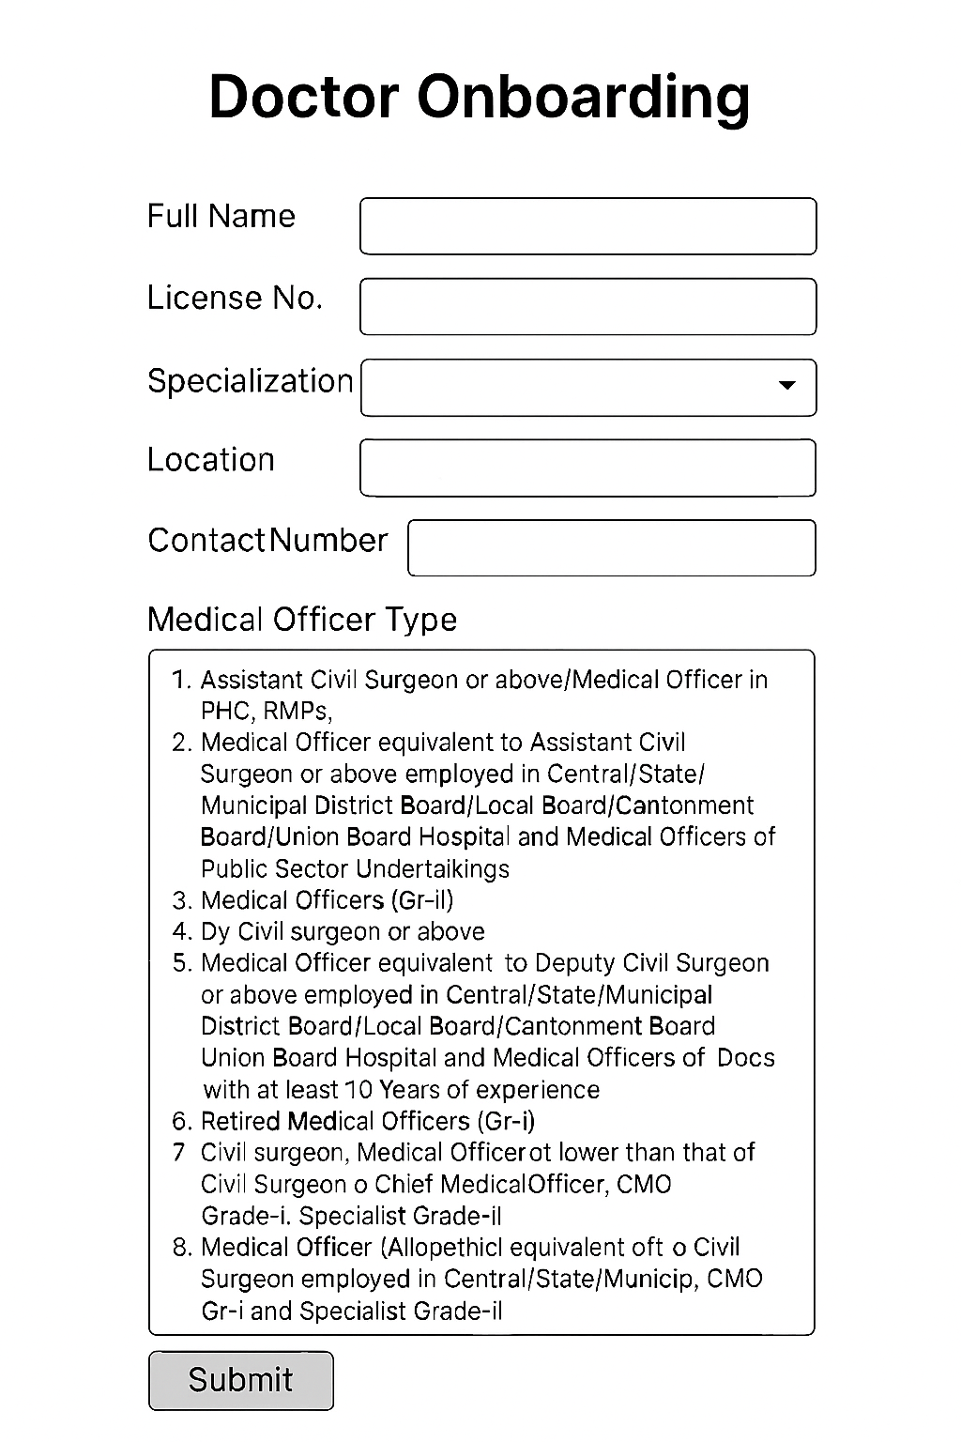

4.2 Doctor Login Page
- Fields & Components:
  - Login ID (Text field, mandatory)
  - Password (Text field, mandatory)
  - Sing-In (button)
  - Forget Password (Link)
  - Sign Up Link (for new doctors)
- Business Rules:
  - After Successful Login, Doctors should move to its Dashboard page.
  - Clicking Signup Link should open the Doctor Onboarding Page.
  - Clicking Forget Password should let the user to reset their password using OTP given on their Mobile Number or other Aadhar based Authentications.
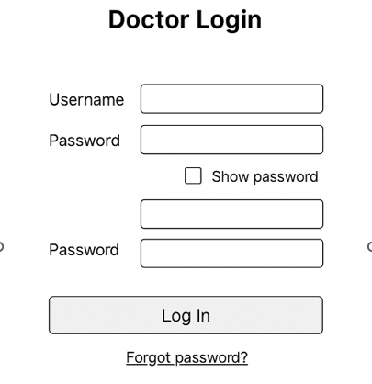

4.3 Doctor Dashboard Page
- To provide doctors with an overview of pending medical review proposals and allow them to upload reports after consultation.
- Fields & Components:
  - Doctor Name (Display Text)
  - Logout (button)
  - Pending Medical Reviews: button
  - Approved Proposals: button
  - Proposal List Table
    - Proposal ID (Clickable link)
    - Customer Name
    - Appointment Date & Time
    - Coverage Amount
    - Status (Pending / Completed)
    - Action (View Details / Upload Report)
- Business Rules:
  - Clicking the Proposal ID should open Customer Profile page for the respective proposal.
  - Clicking Pending Medical Reviews should give the list of all the proposals pending for medical review.
  - Clicking Approved Proposals should give the list of approved proposals.
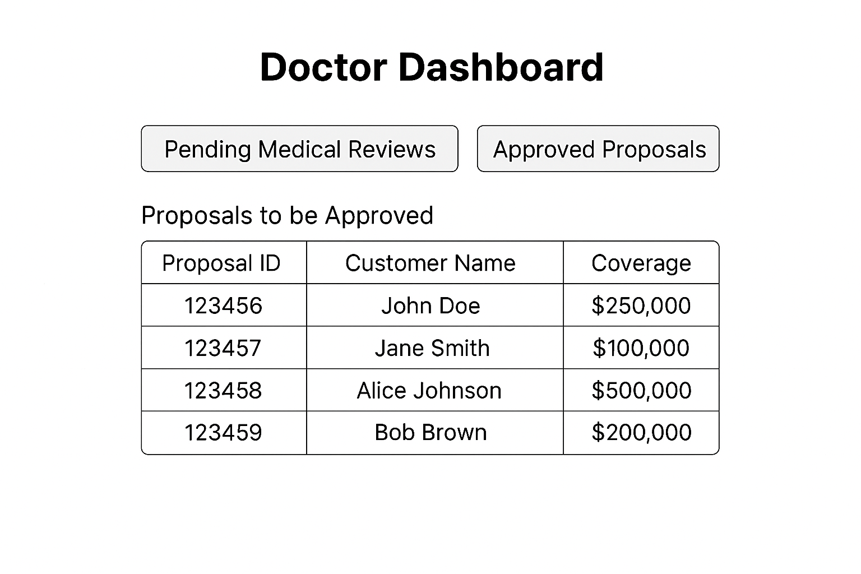

4.4 Customer Profile Page
- To display customer details linked to policy proposals and allow scheduling of medical review appointments.
- Fields & Components:
Customer Details: Text (To Separate Section)
  - Full Name (Text field, read-only)
  - Age (Text field, read-only)
  - Gender (Optional dropdown)
  - Contact Number (Editable text field)
  - Email Address (Editable text field)

Insurance Details: Text (To Separate Section)
  - Policy Proposal ID (Read-only)
  - Coverage Amount (Read-only)
  - Proposal Status (Read-only: Pending Medical Review / Approved / Rejected)

Medical Review Status: Text (To Separate Section)
  - Appointment Date & Time (Read-only if scheduled)
  - Doctor Assigned (Read-only)
  - Medical Report Status (Pending / Uploaded / Reviewed)

Appointment History: Text (To Separate Section)
  - Table with columns: Date, Doctor, Status, Comments

  - Schedule Appointment (Button)
  - View Medical Report (Button – visible after upload)
  - Policy Approval (button)

- Business Rules:
  - Appointment can only be scheduled if proposal status = “Pending Medical Review”.
  - Appointment history must show all past medical reviews linked to proposals.
  - Clicking Policy Approval should lead the Doctor to Policy Approval Page for Approving/Rejecting the Proposal.

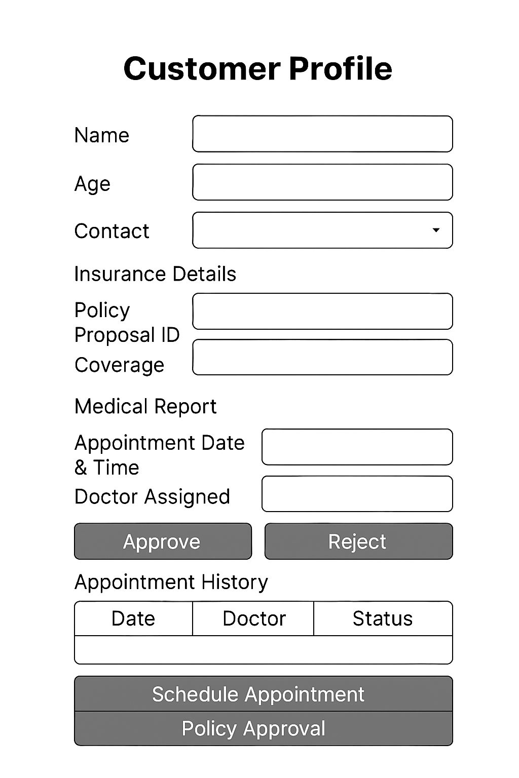

4.5 Appointment Scheduling Page
- This page is used to confirm the Appointment.
- Fields & Components:
  - Customer Full Name (Text field, mandatory): Auto-filled as per proposal.
  - Doctor Name: Auto-filled (current doctor login) and can be changed.
  - Date: Format: DD: -MM-YYYY
  - Time: Timestamp
  - Status: Dropdown
  - Schedule: Button

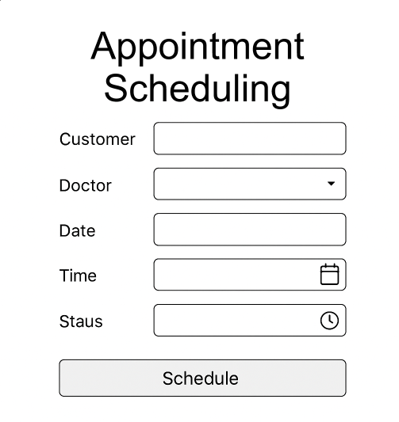

4.6 Medical Report Page
- To allow doctors to upload the medical review report (if needed) for a customer after the appointment.
- Fields & Components:
  - Customer (Read-only field)
  - Doctor (Read-only field)
  - Report Details (Text field for summary)
  - Upload File Section (Drag & drop or click to upload PDF/JPG)
  - Submit (Button)
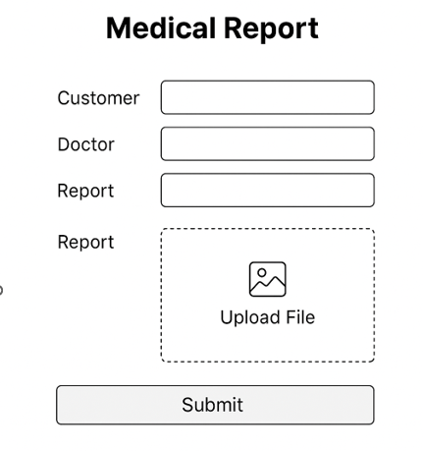

4.7 Policy Approval Page
- To allow doctors to approve or reject the policy proposal based on guidelines.
- Fields & Components:
  - Customer Name: Auto-filled from Proposal
  - Proposal ID: Auto-filled from Proposal
  - Coverage Amount: Auto-filled from Proposal
  - Appointment Date: Auto-filled
  - Doctor Name: Auto-filled
  - Medical Report: Option to Upload
  - Approve (Button)
  - Reject (Button)
  - Comments Box (mandatory if rejecting)
  - Download Report (Button)
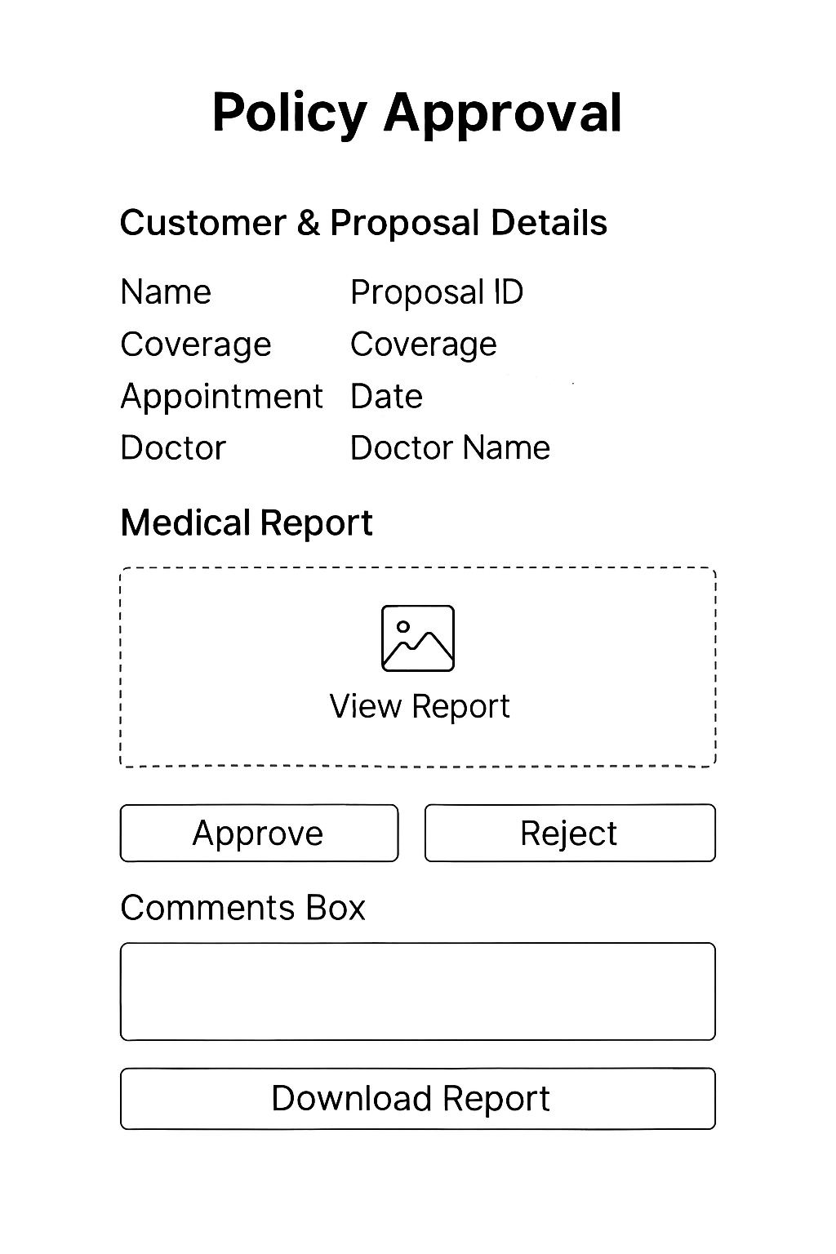

5. Workflow
The workflow for the Medical Appointment System is as follows:
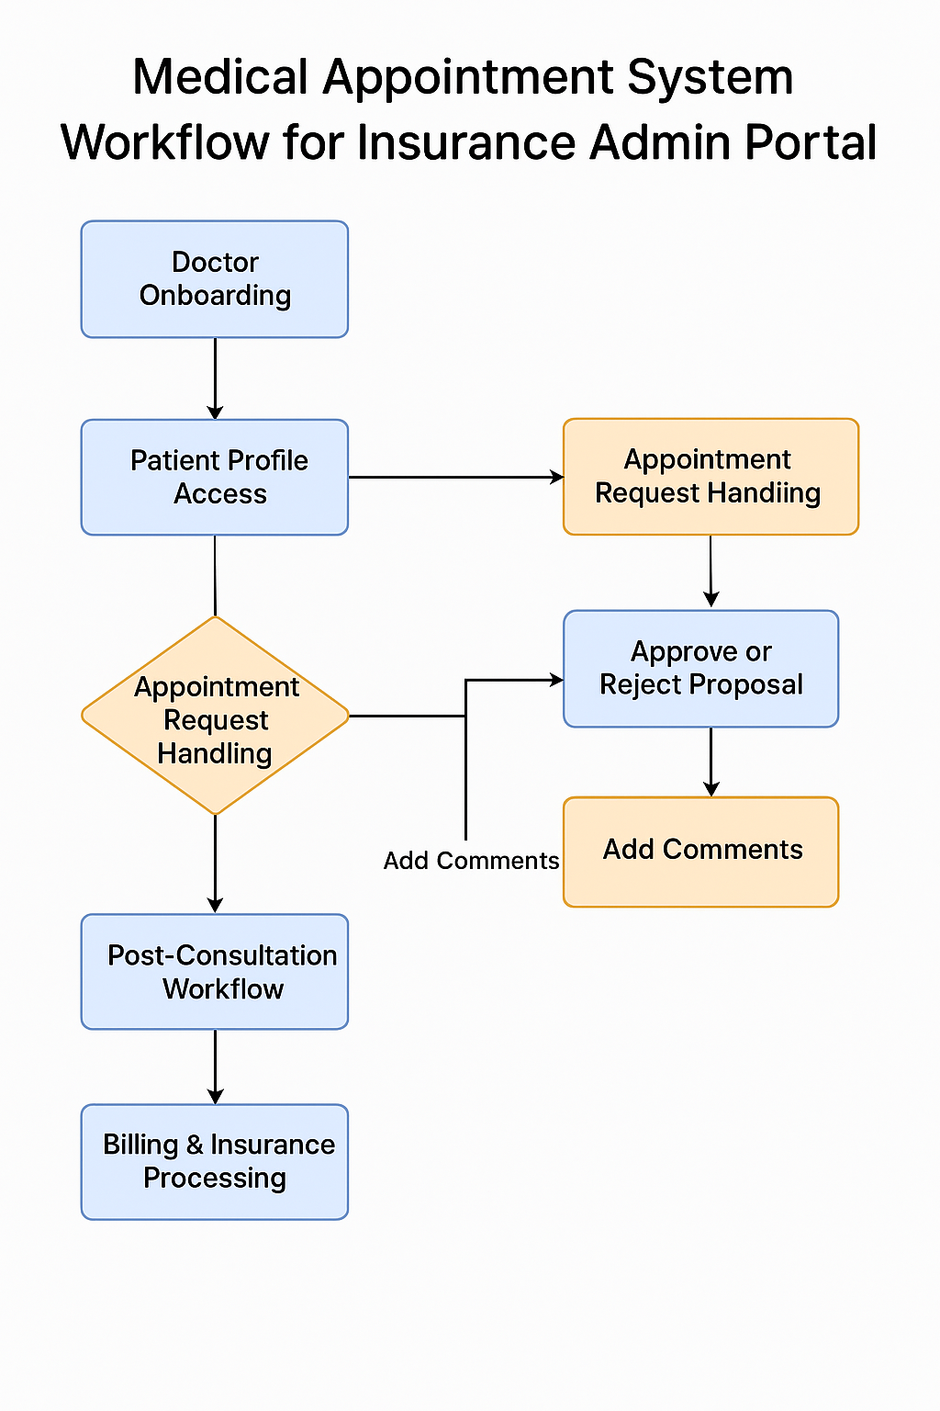

6. Test Case

TC ID | Functionality | Test Case Description | Input Data | Expected Result | Type
TC_001 | Doctor Onboarding | Onboard doctor with valid details | Name, License No, Specialization | Doctor profile created successfully | Positive
TC_002 | Doctor Onboarding | Onboard doctor without license number | Name, Specialization only | Error: “License number required” | Negative
TC_003 | Credential Verification | Verify doctor with valid license | License No = valid | Credentials verified | Positive
TC_004 | Credential Verification | Verify doctor with invalid license | License No = invalid | Error: “Invalid license number” | Negative
TC_005 | Approved Doctor List | Display only approved doctors | Approved doctor profiles exist | List shows only approved doctors | Positive
TC_006 | Approved Doctor List | Display list when no approved doctors | No approved doctors | Message: “No doctors available” | Negative
TC_007 | Customer Details | Display linked customer details | Proposal ID = valid | Customer details displayed | Positive
TC_008 | Customer Details | Display details for invalid proposal ID | Proposal ID = invalid | Error: “Proposal not found” | Negative
TC_009 | Customer Edit | Update contact info | Mobile No updated | Update successful | Positive
TC_010 | Customer Edit | Attempt to edit proposal details | Proposal amount changed | Error: “Proposal details cannot be edited” | Negative
TC_011 | Appointment Scheduling | Schedule appointment with valid doctor & proposal | Doctor ID + Proposal ID | Appointment scheduled | Positive
TC_012 | Appointment Scheduling | Schedule appointment with unapproved doctor | Doctor ID = unapproved | Error: “Doctor not authorized” | Negative
TC_013 | Notifications | Send notifications on appointment | Valid appointment scheduled | Notifications sent to doctor & customer | Positive
TC_014 | Notifications | Fail notification due to invalid email | Invalid email for customer | Error logged, retry mechanism triggered | Negative
TC_015 | Report Upload | Upload report with mandatory fields | BP, Sugar, ECG included | Report uploaded successfully | Positive
TC_016 | Report Validation | Upload report missing ECG | BP, Sugar only | Error: “ECG mandatory” | Negative
TC_017 | Digital Signature | Upload report with valid signature | Signed report | Accepted | Positive
TC_018 | Digital Signature | Upload report without signature | Unsigned report | Error: “Digital signature required” | Negative
TC_019 | Admin Review | Approve policy after report review | Valid report reviewed | Proposal status updated to Approved | Positive
TC_020 | Rejection Reason | Reject policy without reason | Reason field blank | Error: “Reason mandatory” | Negative
TC_021 | Data Encryption | Verify encryption of stored reports | Access DB | Data encrypted | Positive
TC_022 | Access Control | Unauthorized user tries to view report | User role = Customer | Error: “Access denied” | Negative
TC_023 | Audit Logs | Check logs after appointment scheduling | Appointment created | Log entry present | Positive
TC_024 | Delete Health Info | Delete health info on customer request | Customer request valid | Health info deleted securely | Positive
TC_025 | Delete Health Info | Attempt delete without authorization | Unauthorized request | Error: “Not permitted” | Negative

